Lab Experiment No. 03
Design an IPv4 addressing scheme and implement subnetting in a small network using Cisco Packet Tracer

Objective:
To design an IPv4 addressing scheme and implement subnetting in a small network using Cisco Packet Tracer on the example 192.168.100.0/25.

Problem Statement:
You are required to design an IPv4 addressing scheme and implement subnetting for a small network using the IP address block 192.168.100.0/25. The network should be divided into subnets and the addressing scheme must be assigned to hosts and network devices using Cisco Packet Tracer.

Theory:
Subnetting is the process of dividing a single network into multiple smaller networks (subnets). This improves network management, security, and efficient use of IP addresses.

The given network address is 192.168.100.0/25. The /25 prefix means that the first 25 bits are reserved for the network portion, leaving 7 bits for host addresses.

Number of hosts per subnet = 2^7 - 2 = 126 usable addresses.

Therefore, the given address space (192.168.10.0/25) provides one subnet with the following details:
- Network Address: 192.168.100.0
- First Usable Address: 192.168.100.1
- Last Usable Address: 192.168.100.126
- Broadcast Address: 192.168.100.127

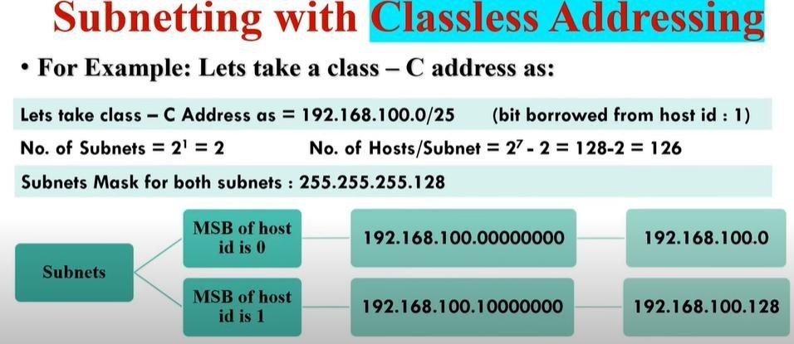

Subnetting helps in logical distribution of IP addresses to different devices such as PCs, switches, and routers.

Solution:
Step 1: Open Cisco Packet Tracer and create a small network topology with two PCs connected via a switch and a router.

Step 2: Assign IP addresses from the subnet 192.168.100.0/25 to each device:
- PC1: 192.168.100.10/25, Gateway: 192.168.100.1
- PC2: 192.168.10.20/25, Gateway: 192.168.100.1
- Router (Interface connected to switch): 192.168.100.1/25

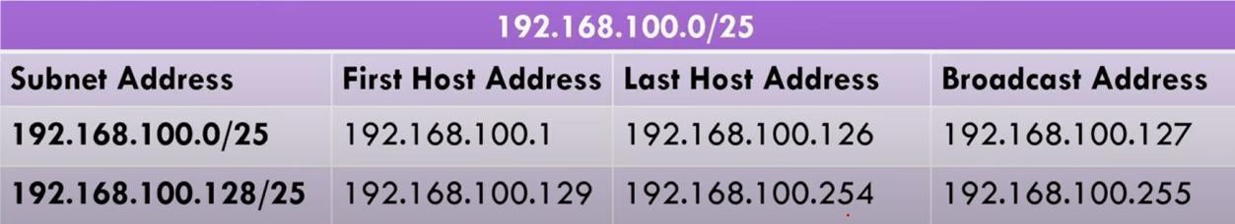

Step 3: Configure the devices in Packet Tracer with the assigned IPs. Step 4: Test connectivity by pinging from one PC to another PC.

The diagram below represents the logical setup of the network:
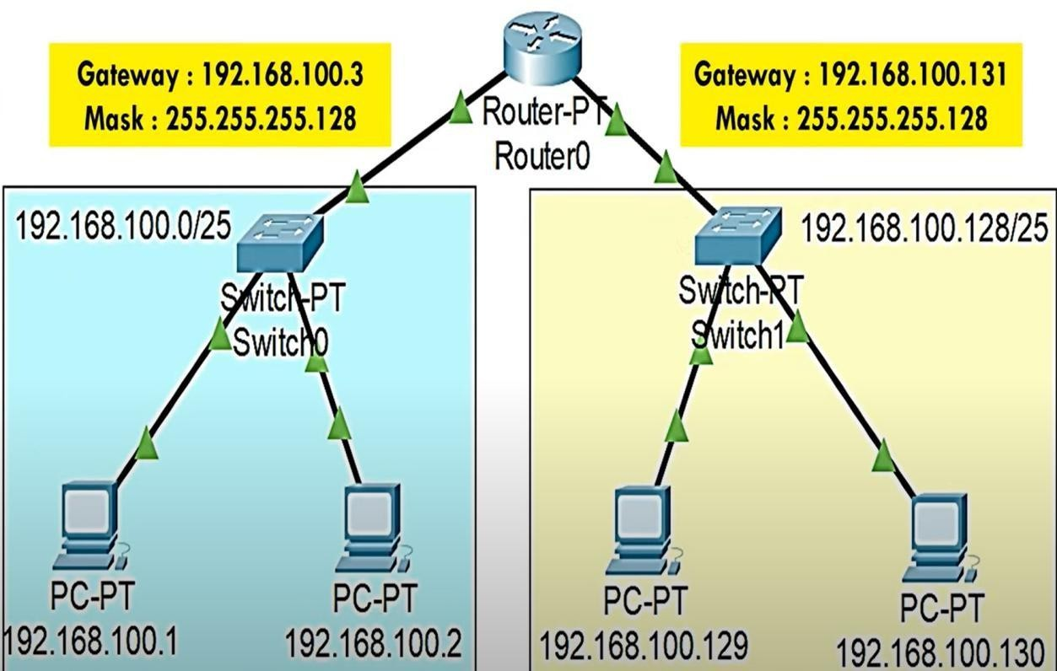
[Network Diagram: Router connected to Switch, Switch connected to PC]

Output:
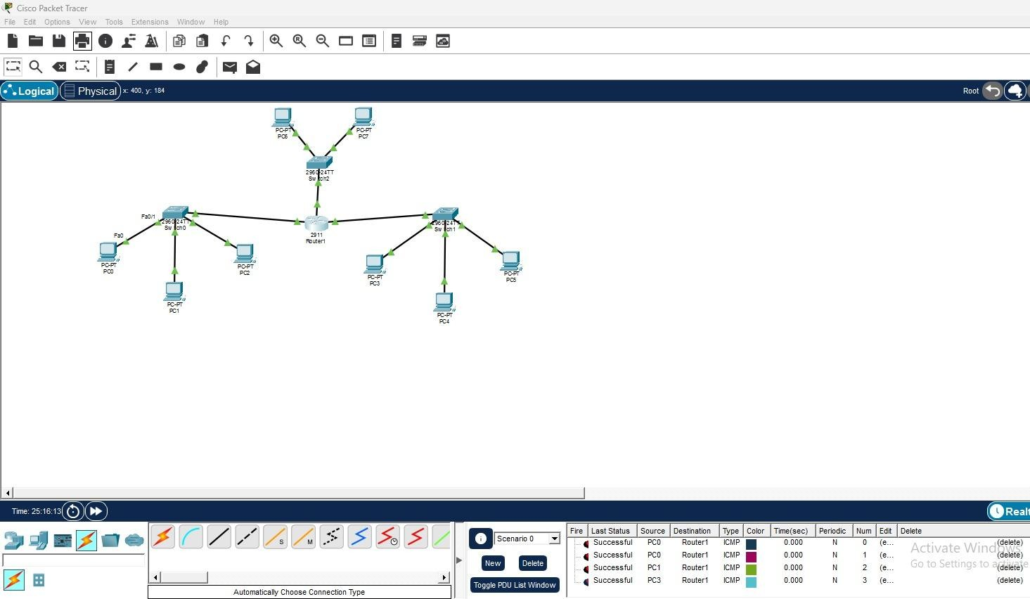

Conclusion:
The IPv4 addressing scheme using the 192.168.100.0/25 network was successfully implemented in Cisco Packet Tracer. Both PCs were able to communicate with each other using the assigned subnet, demonstrating correct subnetting and addressing.

